# **LAMPIRAN E**

***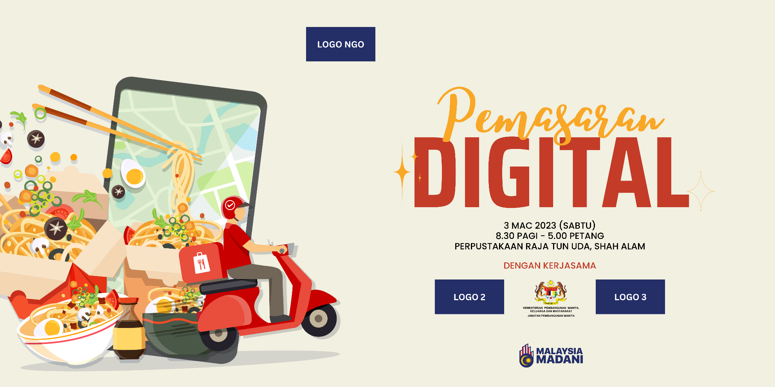*FORMAT *BACKDROP/ BANNER/* BUNTING**